**A CASE STUDY**

This short, qualitative note shows how fitting **SVI** curves to the **near-term implied volatility surface** (per expiry) can inform volatility-trading decisions. Focusing on late August 2025—when SPX pressed all-time highs with VIX subdued—we track the **day-by-day** evolution of the surface, comparing **ATM** to the **wings** across short tenors to flag an atypical **right-wing (OTM call) richening**. We translate that read into a **risk-defined, relative-value** expression—fading the rich short-dated upside while holding modest longer-tenor/downside exposure—with **clear entry/exit criteria** tied to **surface normalization** rather than price alone. The case includes the charts, the trade implementation, and the outcome, plus brief takeaways on **waiting for confirmation**, **sizing small**, and **closing on re-flattening**. This is an educational example; real positioning and sizing may differ.

**Market Context**

In this case study, I evaluate **SPX** and **VIX** while modeling SPX’s near-term implied volatility with **SVI** (Stochastic Volatility Inspired; Gatheral, 2005) to build intuition about short-horizon market moves. I present the key observations that informed the trading idea by reviewing the market **day by day** and showing how the surface evolved.

**August 27, 2025**

The market printed a **new high** while **VIX** stayed relatively low. The near-term **IV surface** (SVI fits by expiry) was low overall, but the **right wing (OTM calls)** was notably elevated—deviating from the usual equity “smirk,” where downside puts are richer. Given **volatility clustering** and the tendency for **rising vol** to coincide with drawdowns, this right-wing richening suggested a potential mean-reversion/reversal setup. I **waited for confirmation** and used the SVI fits to monitor whether the dislocation persisted across tenors.

**August 28, 2025**

Price pushed to a **fresh high** while **VIX** stayed low (brief dip, then a small intraday bounce). Across expiries, **overall IV compressed**, yet the **right wing (short-dated OTM calls)** stayed **elevated versus ATM/left**—an extension of yesterday’s dislocation. This mix (ATH + cheap index vol + rich upside wing) is classic late-trend behavior. I treated it as **probationary confirmation**: began a **small, risk-defined bearish RV** stance—fading the short-dated call wing while holding modest downside/longer-tenor exposure—planning to add only if the right-wing premium persisted into the next session.

**August 29, 2025**

After the ATH, **SPX slipped modestly** while **VIX rose** toward its short-term mean and **volume ticked up**. Despite the dip, near-term IV stayed uneven: the **right wing** remained **rich vs. ATM/left**, marking the **strongest upside kink** of the week. That persistence turned the setup **actionable**: I scaled from starter to **small/partial size** in a **bearish relative-value** expression—fading the rich short-dated call wing while carrying modest longer-tenor/downside exposure—aiming to profit from either a **surface re-flatten** or a **shallow spot pullback**.

**September 2, 2025**

The market **gapped down** and **VIX jumped ~10%**. On the near-term surface, the **right wing relaxed** while the **downside skew reasserted**—back toward a more typical equity smile. That was the signal I was waiting for: the targeted right-wing dislocation **normalized** alongside a modest spot drop, so I **closed the bearish RV position** and booked profits.

Together, the figures below trace the daily progression of SPX and VIX alongside the near-term SVI-fit IV surface. They highlight the late-August right-wing richening, the subsequent confirmation, and the eventual re-flattening that triggered the exit.

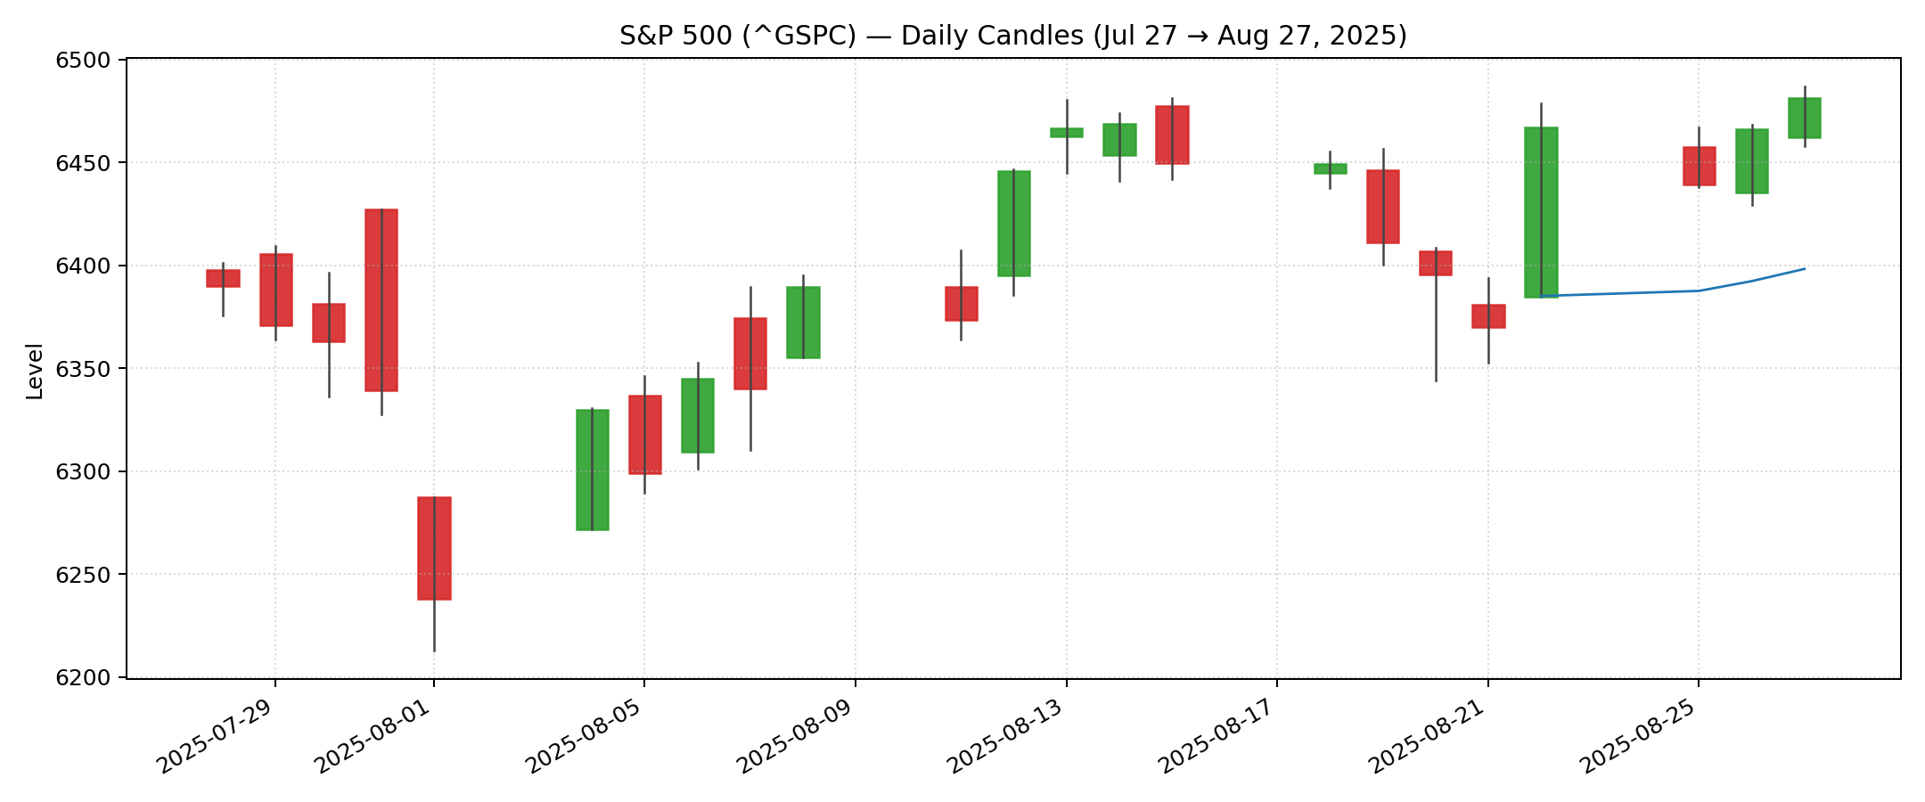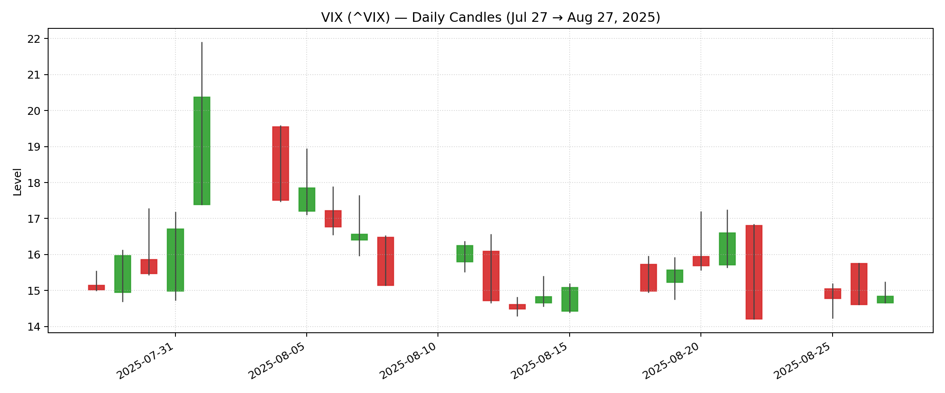

* The Figures shows SPX, VIX and SVI fit for near term options as 8/27/2025

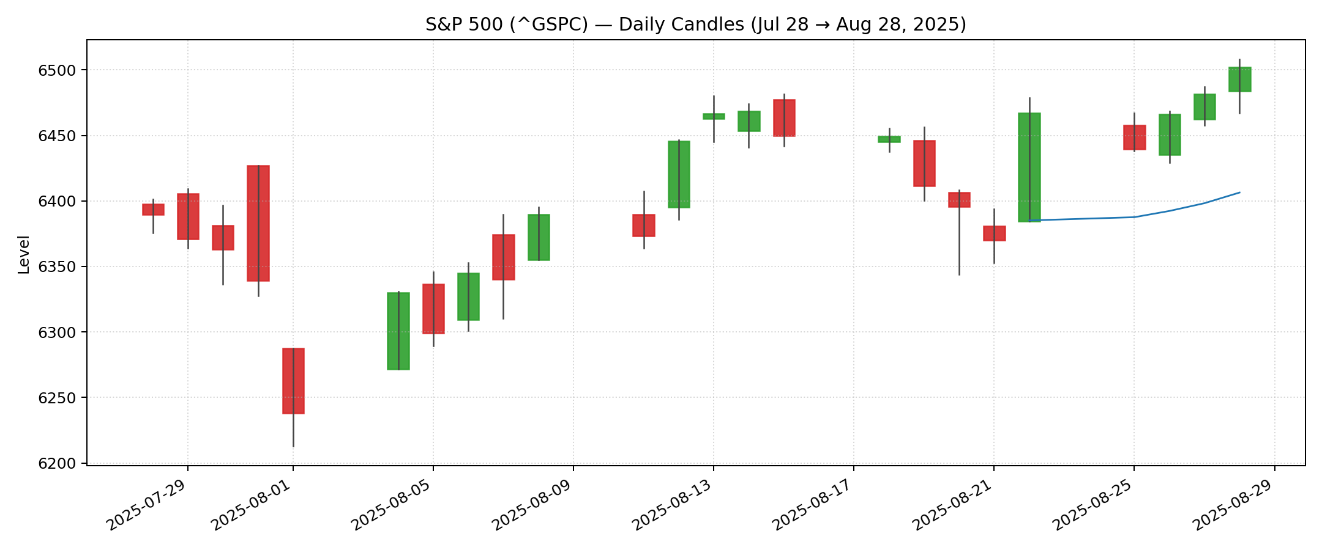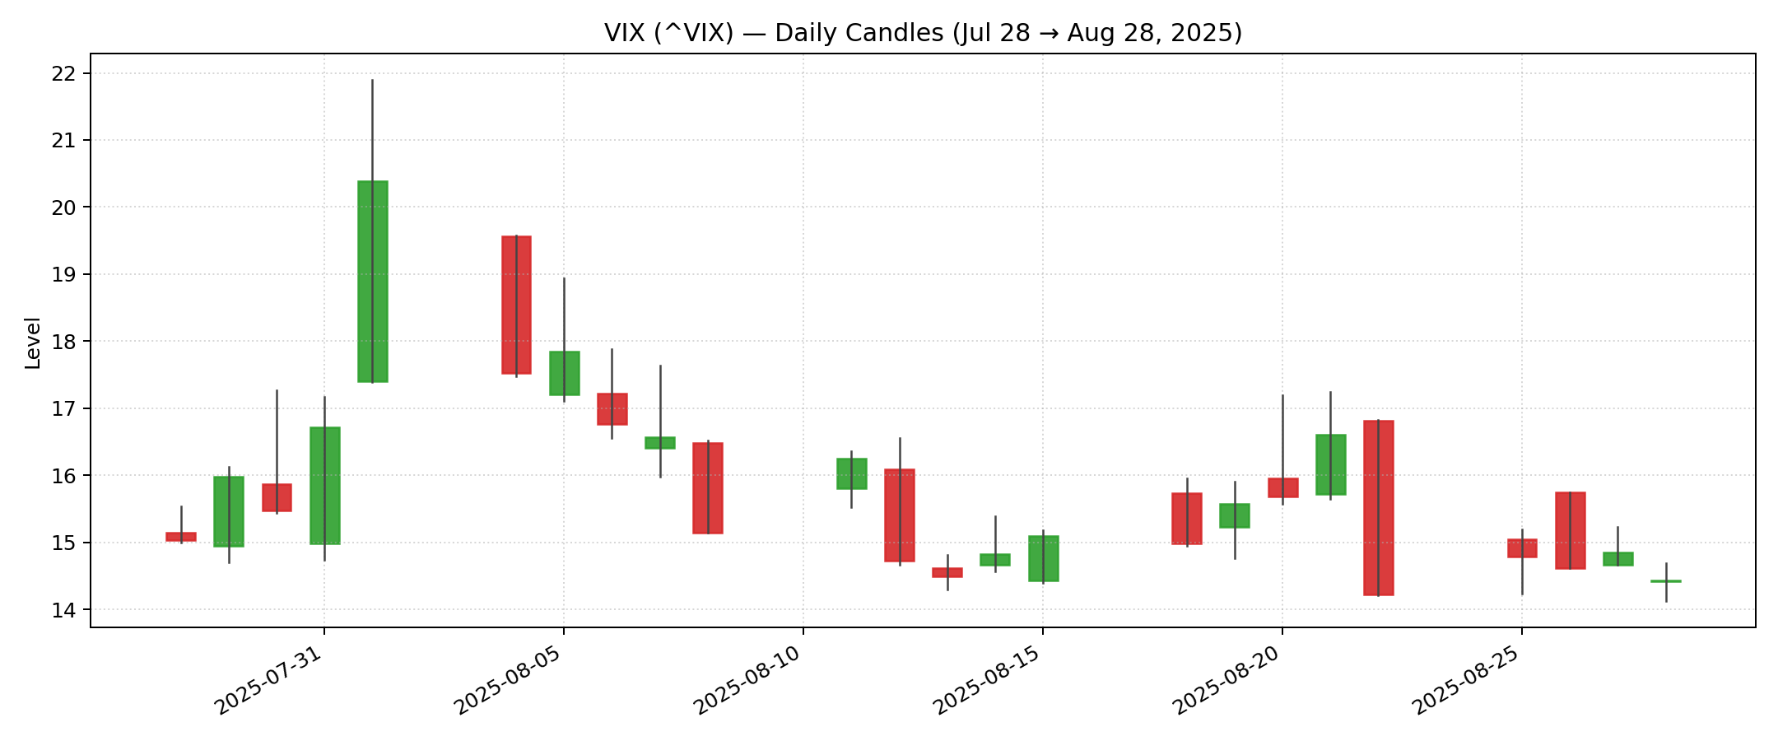

* The Figures shows SPX, VIX and SVI fit for near term options as 8/28/2025

* The Figures shows SPX, VIX and SVI fit for near term options as 8/29/2025

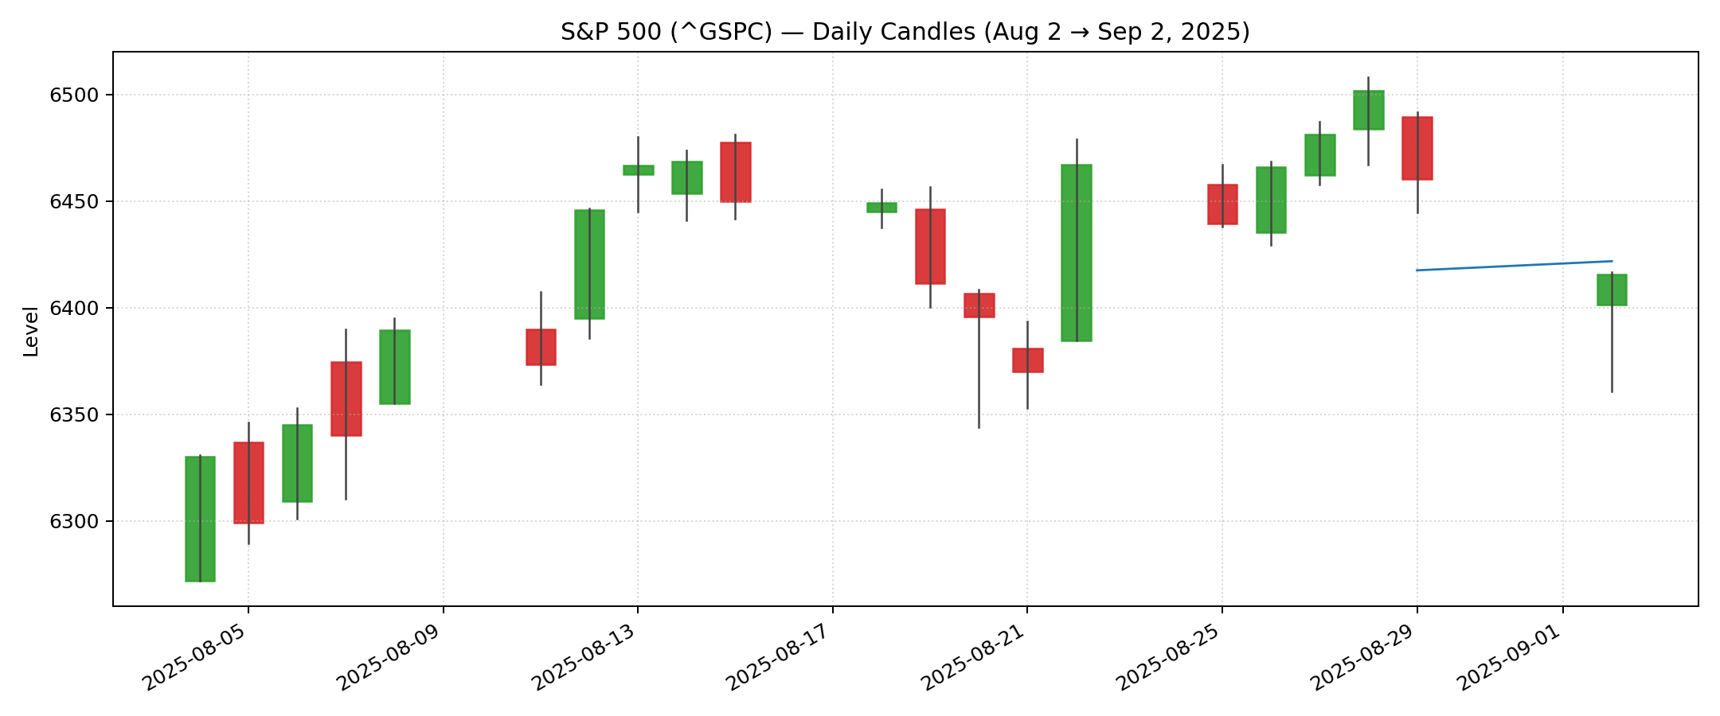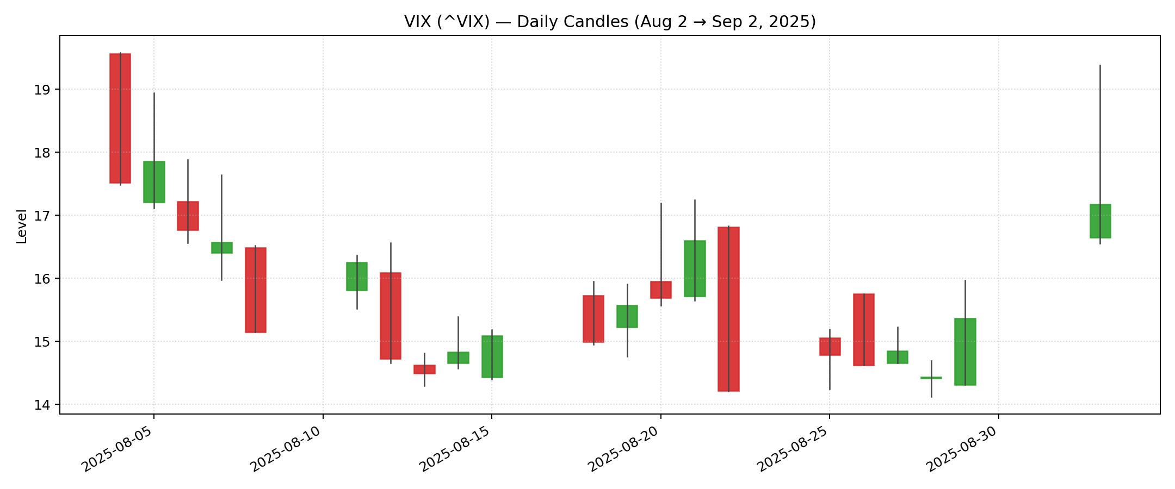

* The Figures shows SPX, VIX and SVI fit for near term options as 9/2/2025